**Skincare Sales Analysis Report**

**Vidhi A Sharma**

**Introduction**

This project was undertaken to analyze skincare sales trends and derive meaningful insights into consumer preferences and purchasing behaviors. Given my personal enthusiasm for skincare and the significant investment I’ve made in these products over the years, I found it both fascinating and necessary to apply data analytics to understand what truly drives sales and consumer choices in the skincare industry.

**Objectives**

* To identify the best-selling skincare brands and products.
* To examine the relationship between product pricing and customer ratings.
* To analyze the distribution of skincare categories and their market performance.
* To gain insights into sales trends using data visualization techniques.

**Methodology**

A structured data analysis approach was employed, using a dataset that includes comprehensive skincare sales information. The dataset was thoroughly cleaned and preprocessed before conducting exploratory data analysis (EDA). Python libraries such as Pandas, Matplotlib, and Seaborn were utilized for statistical analysis and visualization, ensuring a methodical and insightful examination of sales trends.

**Key Findings**

* **Best-Selling Brands:** Clinique and Sephora Collection dominate the market, indicating strong consumer trust and strategic product placement.
* **Pricing vs. Sales:** While luxury skincare commands premium prices (which, yes, I willingly pay), the data shows that affordability remains a key driver of sales volume.
* **Customer Ratings Matter:** Highly-rated products consistently achieve higher sales, reinforcing the idea that customer satisfaction and product efficacy are critical factors in purchasing decisions.
* **Skincare Categories:** Moisturizers and serums lead the market, demonstrating a strong consumer focus on hydration and anti-aging solutions (which, as a dedicated buyer, I can confirm is a priority).

**Visualizations Used**

* Scatter plots to assess the correlation between product prices and customer ratings.

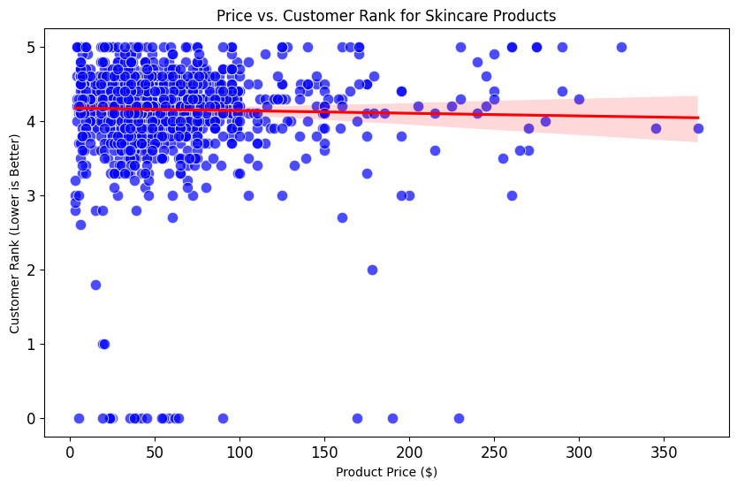

* **Bar charts ranking top-performing skincare brands**

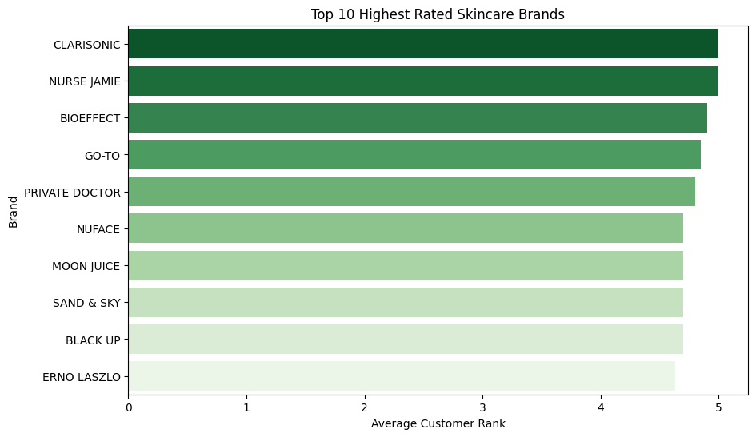

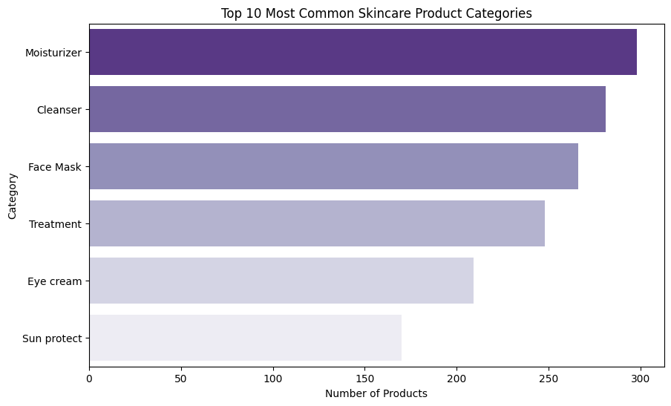

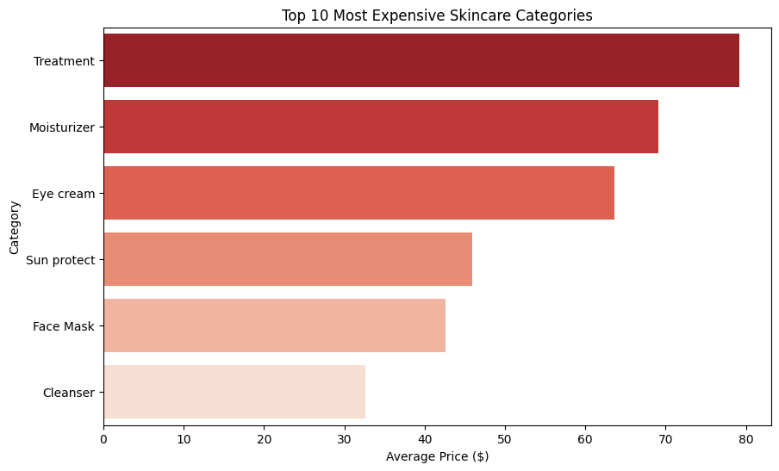

* **Treemaps comparing the most expensive versus best-selling products.**

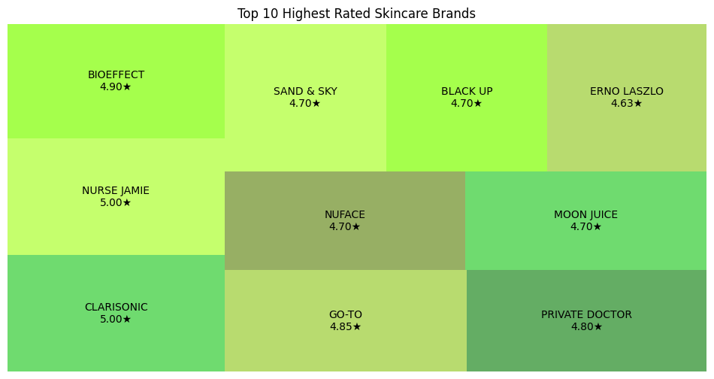

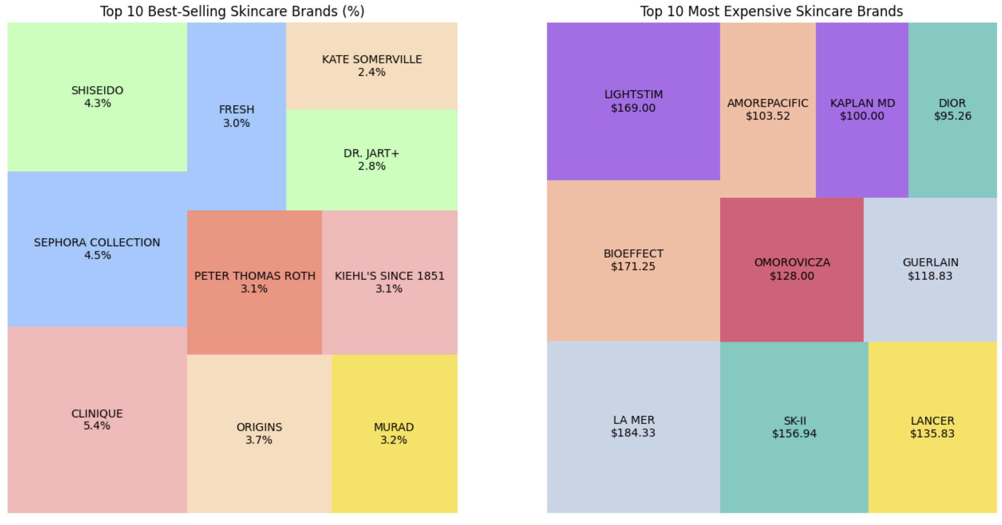

**Conclusion**

This analysis provides key insights into the skincare industry, helping consumers make informed decisions and businesses refine their marketing strategies. The findings emphasize the significance of brand reputation, pricing strategies, and customer satisfaction in influencing sales performance. Additionally, the data confirms what I’ve long suspected—good skincare is an investment, and people (including myself) are willing to spend for quality.

**Future Scope**

* Expanding the dataset to analyze global variations in skincare trends.
* Conducting sentiment analysis on customer reviews to gauge brand perception.
* Leveraging predictive analytics to anticipate emerging skincare trends and consumer behavior.

This project not only validated my passion for skincare but also demonstrated the power of data-driven decision-making in an industry I deeply care about. Now, if only my love for skincare translated into financial sponsorships—until then, I'll continue to research and, of course, spend on the latest serums and creams.

**References**

*Abid, A. A. (n.d.). Cosmetics datasets: Cosmetics ingredients, rank, price and effects on skin. Kaggle.from https://www.kaggle.com/datasets*

*ChatGPT. (2025). Resolved dataset errors and technical troubleshooting[Large language model]. OpenAI. from* [*https://openai.com/chatgpt*](https://openai.com/chatgpt)